

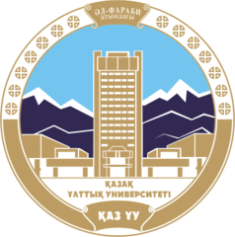



**DEAR STUDENTS!**

**Applications for the spring semester of 2023 (nominations for one semester) have been processed within the framework of the ICM 2022-2023 joint project.** Mälardalen **University and KazNU**

**Please note that the deadline for submitting applications is October 1, 2022.**

**The application must be sent directly to turarbekasem@kaznu.kz and include the following information:**

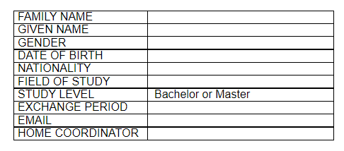

**You will be contacted and provided with information about the application after the nomination.**

**In order to apply, you will need to download the following documents in pdf format:**

* **Transcripts of records (transcript must be submitted in English or in an official translation, which includes all university studies starting from the first semester, even if they were studied at other universities).**
* **Certificate of current training (please use the attached form)**
* **A copy of the identity card (passport or national identity card)**
* **Summary**

**The acceptance notification will be sent by email on November 7, 2022.**

**In the attachment to this email you will also find a file with a course offer for exchange students at the Mälardalen University School of Innovation, Design and Engineering for the spring semester of 2023.**

**You can get acquainted with the course program on the web page: https://www.mdh.se/en/malardalen-university/education/find-education**

**If you have any questions, please feel free to contact us!**